Document Number | HP2
Document Title | Billing Procedures for Providers
Department Ownership | Hand and Upper Limb
Document Type | Procedure
Department Owner | Tim Darch
Document Author | Derrick Chan
Last Edited By | Nick Filevski | Lasted Edited On | 02/12/2014

Purpose

The purpose of this procedure is to outline the steps required to create an invoice for a patient.

Scope

All staff within Hand and Upper Limb involved in billing.

Reference Documents

Definitions

Flowcharts (Other Images)

Procedures

- Patient arrives to appointment and is tea-cupped by reception resulting the patient appointment to turn red in colour:

- At the end of consult treating provider is to click on patients clinical history 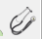 (type notes if necessary) click save

- A list of item numbers will appear in the middle of the screen (if this does not happen, please contact accounts)

- Select the items you wish to invoice the patient by clicking on the box (far left) if you need to bill more than 1 of these items please left click the on the number 0 in the Qty column. Right click if you wish to reduce the number of charges

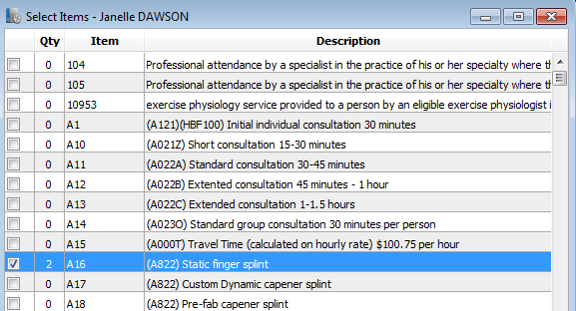

- If you need to pass a message onto accounts you may type it in the box below:

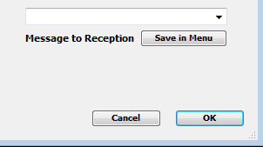

- Once completed click OK.

- Your patient will turn green in colour with item numbers to charge next to their name

- Patient is now ready for accounts to generate an invoice

Appendices

